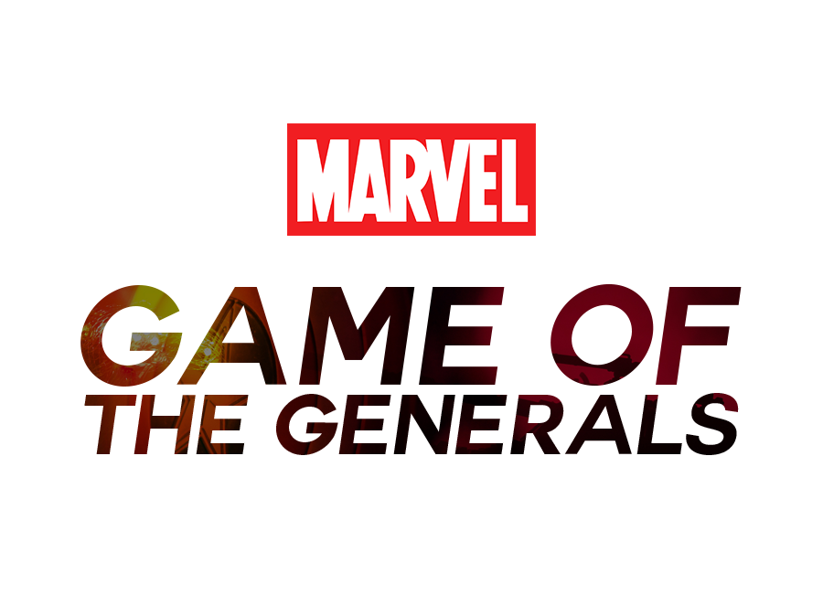

Program Documentation

**Requirements Document:**

[FinalCPT/Project Documentation/Final CPT Program Requirements.pdf](https://github.com/ibattlehd/FinalCPT/blob/master/Project%20Documentation/Final%20CPT%20Program%20Requirements.pdf)

**UI Design Document:**

[FinalCPT/Project Documentation/UI Design Document.pdf](https://github.com/ibattlehd/FinalCPT/blob/master/Project%20Documentation/UI%20Design%20Document.pdf)

**User Manual:**

[FinalCPT/README.md](https://github.com/ibattlehd/FinalCPT#game-of-the-generals---marvel-edition)

**Daily Log:**

[ibattlehd/FinalCPT](https://github.com/ibattlehd/FinalCPT/commits/master)

**Repository Website:**

<https://ibattlehd.github.io/FinalCPT/>